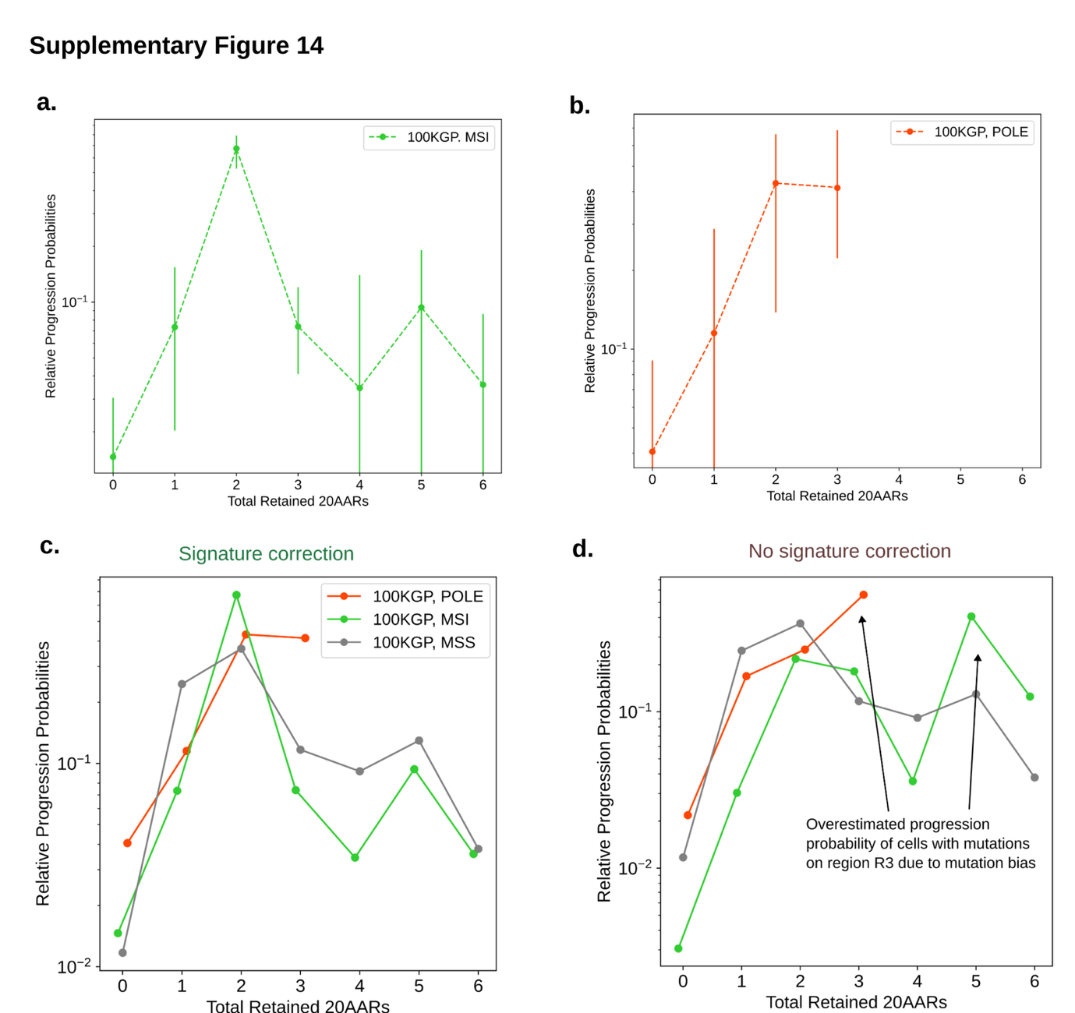Supplementary Figure 14. Signature correction in hypermutant CRCs.
The relative progression probabilities by total number of 20AARs retained in MSI (a) and POLE-mutant CRCs (b) in the 100kGP cohort, with bootstrapped 95% confidence intervals. (c) The relative progression probabilities by total number of 20AARs retained in POLE-mutant, MSI and MSS CRCs 100kGP cohort, display overall agreement, which can be quantified by no significant differences in the progression-weighted mean number of 20AARs (Δ_{MSS-POLE}=-0.22, 95% CI=[-0.62, 0.15], Δ_{MSS-MSI}=-0.29, 95% CI=[-0.67, 0.08], bootstrapping). (d) As in (c) but without correcting for hypermutant mutational signatures. We calculate larger differences in the progression-weighted mean number of 20AARs, that are statistically significant in the case of MSI tumours (Δ_{MSS-POLE,nc}=-0.31, 95% CI=[-0.78, 0.2], Δ_{MSS-MSI,nc}=-1.87, 95% CI=[-2.51, -0.81]). We highlight that the relative progression probability is larger for 5-6 total retained 20AARs for the MSI cohort without correction, due to an indel associated mutation bias to region R3.

